

JOB DESCRIPTION
Post Title: Social Worker

Grade and Salary Scale: I - K

Department and Service: Adult Social Care and Health Integration

Responsible To: Team Manager

Purpose of the Post:

As a qualified social worker in adult social care you will be contributing to the provision of an effective social work service which strives to improve the lives of the residents of Middlesbrough.

You will be working within our team structure:

You will support adults to have a good assessment, clearly identifying needs whilst considering the context that the adult lives in and listening to their voice. You will then plan to help them meet their needs by looking at informal and community based support in addition to providing statutory services to meet their needs. You will also work with adults to safeguard them against abuse and neglect.

Our values | Behaviours & Responsibilities of the Role
  Passion | Show passion in your approach to working with adults ensuring that professional standards are maintained.  To aim to achieve good outcomes for adults and their carers with the wellbeing principle underpinning the work we do.
  Integrity | Comply fully with policy and procedural guidelines taking responsibility to ensure excellent quality of the casework recordings, in line with the timescales set out within our recording standards.  Communicate with adults and their carers being open and truthful with them even when delivering difficult messages.
Creative   | Develop and design appropriate plans to meet the identified needs of the adults and their carers and arrange for the implementation of such plans.  Capture the voice of the adult through direct work, ensuring your practice is person centred.
  Collaborative | Work with other Social Work professionals feeding back to the Team Manager any concerns in relation to the effective provision of services and policies.  Work closely with partner agencies, building strong relationships to ensure that the best results for adults and their carers are achieved.
Focus   | Providing appropriate ongoing support to adults and their carers as the key worker.  Committed to continuous improvement to ensure that the adults and their carers are receiving the best support available.

Corporate Responsibilities:

- We will make every reasonable effort to supply the necessary employment aids, equipment or adaptations to enable employees to perform the full duties of the job in accordance with the Equality Act 2010 where a post holder is disabled.

- You will

  - demonstrate a commitment to the principles of equality of opportunity and fairness of treatment in relation to employment issues and service delivery.
  - respect all confidentialities and principles and practices of the Data Protection Act.
  - comply with Health and Safety policies and legislation.
  - be committed to continuous personal development, including Middlesbrough learns.
  - demonstrate a commitment to the safeguarding of children and vulnerable adults, highlighting any areas of concern with the appropriate service and adhering to the policies of the Council relating to these issues.

- The above duties and responsibilities cannot totally encompass or define all tasks which may be required. The outlined duties and responsibilities may, therefore, vary from time to time without materially changing either the character or level of responsibility: these factors are reflected in the post.

General / Miscellaneous

1. The above duties and responsibilities cannot totally encompass or define all of the tasks which may be required of the postholder. The outline duties may therefore vary from time to time without materially changing either the character or level of responsibility. These factors are reflected in the post grade.

2. Middlesbrough Council is totally committed to continuous organisational and employee development. The postholder is required to participate fully in all initiatives, which facilitate continuous improvement in both service quality and employee development and performance.

3. All employees are expected to demonstrate a commitment to the principles of equal rights both in relation to employee issues and service delivery and adhere to the policies of the Council in the performance of their duties.

PERSON SPECIFICATION
For the purposes of recruitment and selection, you will be assessed against Our Values and the criterion which are marked as Essential / Desirable in the Qualifications and Knowledge & Experience section.
Our Values

Our Values are a critical element of our strategy to create a brighter future for Middlesbrough. They will be at the heart of everything we do and will be the foundation for how we operate, behave and make decisions. Having these values will help you be the best you can be and help Middlesbrough to grow and thrive.

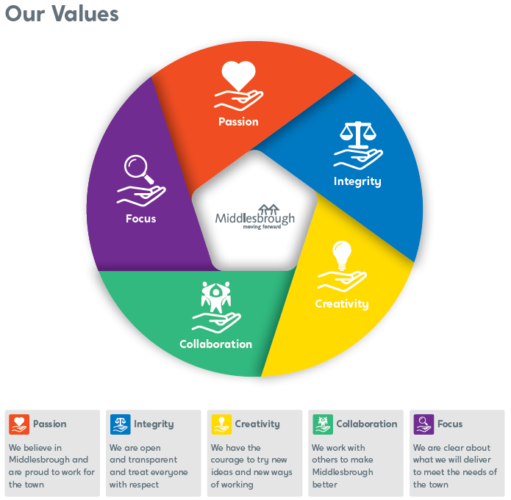

PERSON SPECIFICATION

For the purposes of recruitment and selection, you will be assessed against Our Values and the criterion marked as Essential/Desirable.

I – Interview, A – Application, P – Presentation/Assessment

Value |  | Essential | Desirable | I, A P
Passion | Practical experience of working with adults, their families and informal carers |  |  | IA
 | Have successfully completed the Assisted Supported Year of Employment (ASYE) or committed to the successful completion of this year. |  |  | A
 | Have demonstrated a passion for development post qualification (e.g. BIA assessor, Practice Educator Award) |  |  | IA
Integrity | Hold a recognised Social Work Qualification. |  |  | A
 | Be registered with Social Work England. |  |  | A
 | Hold a full driving licence and have use of a vehicle. |  |  | A
 | Have a working knowledge of the relevant social care legislation (The Care Act 2014; The Mental Capacity Act 2005 and the Deprivation of Liberty Safeguards; Human Rights Act 1998) |  |  | IA
 | Be able to communicate effectively with adults with a range of communication needs and language requirements. |  |  | I
 | Be able to confidently share assessments with families and deal with the challenge that this may present, in a respectful and professional manor. |  |  | I
Creative | Continuous improvement with a willingness to learn and develop practice. |  |  | I
 | Experience and ability to develop plans and implement appropriate care packages. |  |  | IA
 | Be creative when working with adults to ensure that they have a voice in your assessments. |  |  | IA
 | Be reflective when working with adults and their carers and be willing to try creative new approaches if you see that change is necessary. |  |  | I
Collaborative   | Ability to work purposefully in partnership with adults, their families and carers other Professional agencies. |  |  | IA
 | Have demonstrated an ability to work collaboratively within the safeguarding adults framework |  |  | I
 | Develop positive relationships with team members, adults and their families and carers. |  |  | I
 | Be able to share information confidently with other professionals in meetings in order to ensure the best outcomes for adults and their carers |  |  | I
 | Be confident in your role and experience when representing the local authority and social care during formal meetings with partner agencies, adults and their families and carers |  |  | I
Focus   | Ability to work under pressure and meet deadlines by utilising excellent organisational skills. |  |  | I
 | Undertake high quality assessments with adults and their Carers. |  |  | I
 | Positive attitude to supervision, support, and training. |  |  | I
 | Be able to prioritise tasks to prevent any family from being subject to drift or delay. |  |  | I
 | Be able to acknowledge limitations in knowledge or experience and seek appropriate support from mangers, peers, and partner agencies. |  |  | IA

